Installation Plan

Contents

1 Background 1

2 Installing FMC Work Item Save plugin 1

2.1 Installing Scripts 2

2.2 Example 2

​​

​​

# Background

This document intends to describe the steps to install script files with the purpose to limit the Risk Record to linking one Harm and one Hazardous Situation.

# Installing FMC Work Item Save plugin

This extension for Polarion makes it possible to check the link rule (one-to-one) before saving a Risk Record.

Download the extension on <http://extensions.polarion.com/extensions/134-fmc-work-item-save>

After downloaded, unzip 4-workitemsave_extension_bundle.zip and copy the extension file "com.polarion.fme.workitemsave.actions_X.X.X.jar" to your existing "<Polarion Installation Folder>/polarion/extensions/userextensions/eclipse/plugins" folder.

The "extensions" folder should already exist, the "userextensions" (you can choose any name for this folder), "eclipse" and "plugins" folder must be created if not exist.

Create two new folders: "<Polarion Installation Folder>/scripts" (if not exist) and within this folder a new folder "workitemsave". For the moment this folder is empty, we will fill it with scripts later.

Restart Polarion.

## Installing Scripts

Copy the files **hm-pre-save.js** and **hs-pre-save.js** into <Polarion Installation Folder>/scripts/workitemsave.

No need to restart. The scripts are ready to use.

## Example

Scenario 1: Trying to link more than one Hazardous Situation to a Risk Record.

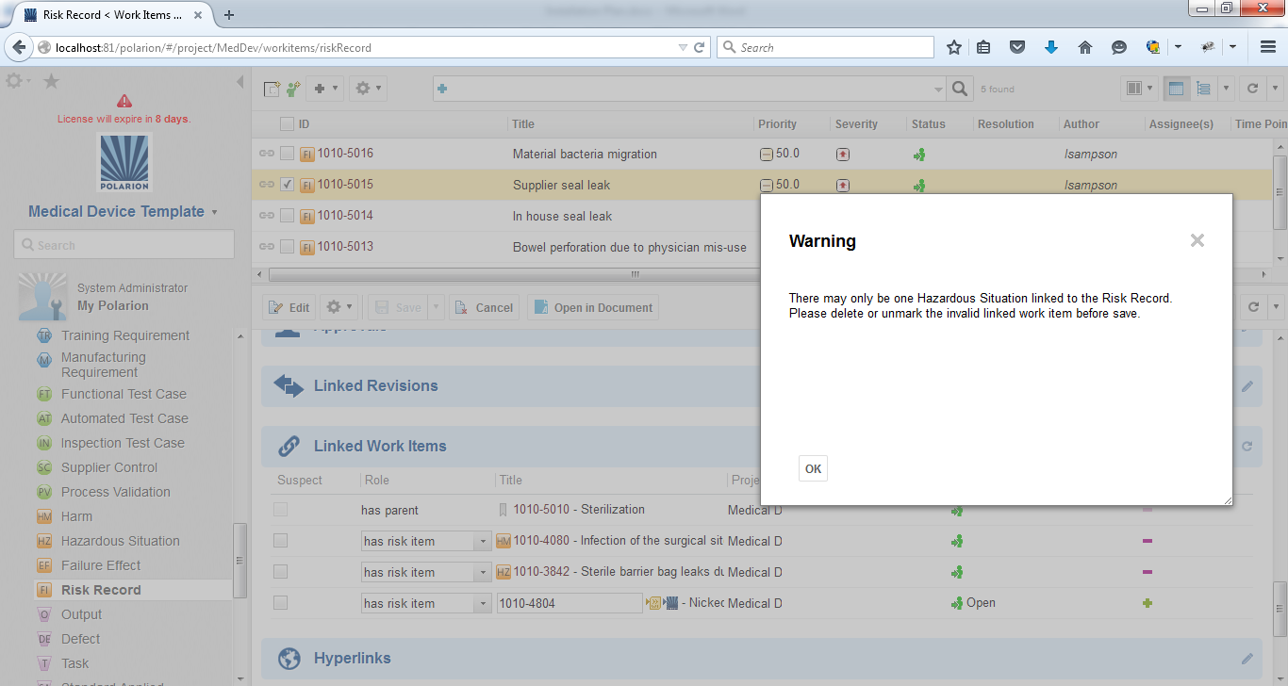

Scenario 2: Trying to link more than one Harm to a Risk Record.

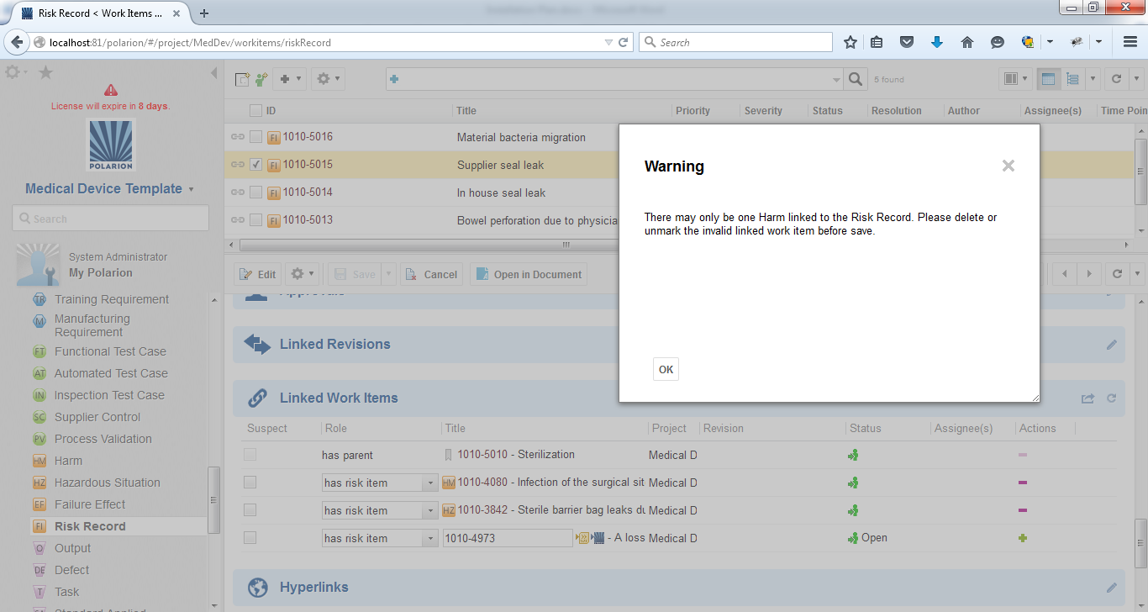

Scenario 3: Trying to create a new Harm linked to a Risk Record.

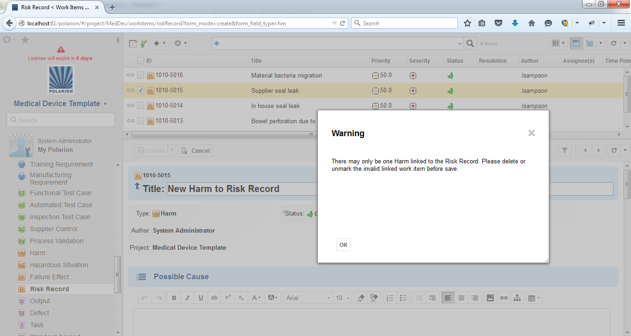

Scenario 4: Trying to create a new Hazardous Situation linked to a Risk Record.

